**IOT MINI PROJECT REPORT C01**

**Group Members:**

Ritwik Mukherjee(18101C2020)

Chaitanya Desai(18101C2021)

Siddharth P(18101C2016)

**About This project:**

Now imagine, sitting in your home, minding your own business, listening to music or doing some household. Someone rings the bell, and it goes unnoticed.

This is a problem, that teenagers face when they are alone at home.

This is a problem that we face far too many times. So, to overcome this problem, we have come up with this solution.

So, when someone rings the doorbell, a photo of who is on the door is captured, and you will

receive that picture along a push notification to your phone(any with proper *internet

connection).

*An internet connection is always required for this to work.

**Component and Supplies**

1. Surveillance camera

2. NodeMcu

3. Single relay

4. Server to host

5. Doorbell/ push-button

6. Breadboard

7. Jumper wire

8. RCA cables

9. Any phone with internet

**BLOCK SCHEMATIC**

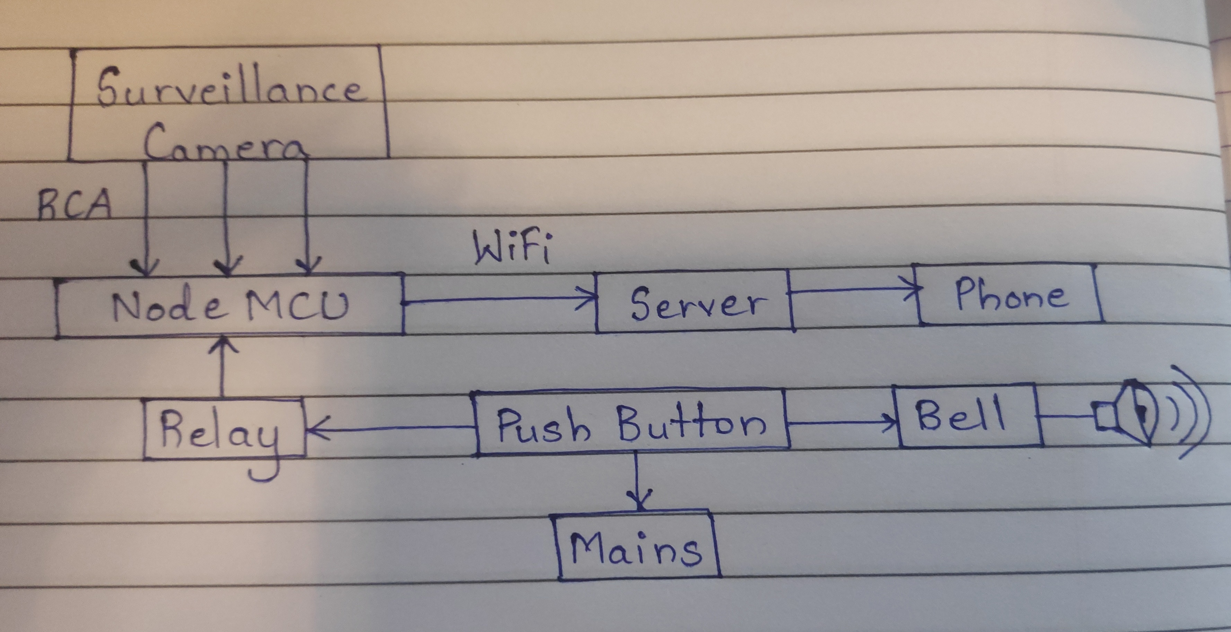

**Working**

An app will be used to push the user for notifications.

The micro controller will monitor for door bell presses, within some delay.

When the push button is pressed, the bell rings and the microcontroller takes input from tge surveillance camera and sends the data to the cloud which in turn sends it as a push notification to user's mobile phone.

**Software Requirements:**

Arduino IDE

Android Studio(Mobile Application)